Why Do Businesses in Dubai Need Branding?
Focus keyword: Branding for Businesses in Dubai
Meta title: Why Do Businesses in Dubai Need Branding?
Meta description: Discover why branding is essential for businesses in Dubai to build trust, stand out from competitors, and drive long-term growth in a competitive market.
Feature image

Dubai is among the rapidly expanding business centers in the world. Every day, new companies are being introduced. In any industry, customers are presented with a variety of choices. Companies have to be conspicuous. Branding assists the firms in creating identity and recognition. It demonstrates their identity and what they have to offer. Businesses that have not been branded find it difficult to attract attention. Customers have faith in brands they are familiar with. Branding establishes such recognition in time. It develops emotional appeal amongst audiences. The citizens of Dubai are not indifferent towards quality and professionalism. A strong brand reflects both. Branding also facilitates the long-term business growth. It enhances customer loyalty and recall. Investors also prefer branded businesses. Easy branding guides marketing. In this blog, we explain why branding has become essential for businesses in Dubai.

Branding Creates Strong Market Identity
Good brand identity makes businesses memorable. Branding determines the perception of people towards a company. It forms perception using images and communication. The customers do not forget businesses with definite identities. Identity assists businesses in expressing their values. It also isolates them among the competitors. Dubai has numerous companies that provide similar services. Identity becomes the determining factor. Familiarity and trust are created through branding. Customers are more comfortable with familiar brands. Identity also improves recognition across platforms. From websites to physical locations, consistency matters. A clear identity saves marketing effort. Customers instantly understand what the business represents. Strong identity supports long-term positioning. It ensures the brand stays relevant. Identity is the foundation of business success.


Branding Builds Trust with Customers
Trust drives customer decisions strongly. Branding builds trust through consistency and clarity. Consistent visuals show professionalism. Clear messaging reduces confusion. Customers trust businesses that look reliable. Branding shows commitment and seriousness. It reflects attention to detail. Trust grows when branding matches experience. Customers feel confident when expectations are met. Trust leads to repeat business. Loyal customers recommend trusted brands. Recommendations build credibility naturally. In Dubai, trust influences high-value purchases. Branding supports transparent communication. It shows stability in competitive markets. Trust also protects businesses during challenges. Customers forgive trusted brands more easily. Branding turns first-time buyers into loyal clients.


Branding Supports Business Growth
Growth requires visibility and recognition. Branding supports both effectively. Strong brands expand faster into new markets. Customers recognize them easily. Expansion becomes smoother with branding. Marketing campaigns perform better. Branding reduces the need for reintroduction. Customers already know the brand promise. Growth becomes consistent and controlled. Investors feel confident investing in branded companies. Partnerships form more easily. Branding also supports franchise models. Teams align better during expansion. Training becomes simpler with brand guidelines. Growth without branding confuses. Branding gives structure to growth. It ensures the business scales without losing identity.

Branding Improves Digital Presence
Digital platforms dominate Dubai’s business environment. Branding improves digital performance significantly. Consistent branding increases engagement online. Customers trust branded websites more. Visual consistency enhances user experience. Branding helps content stand out on social media. Ads perform better with a clear identity. Branding improves click-through rates. It also increases brand searches. Customers remember branded businesses easily—email marketing benefits from brand recognition. Branding supports storytelling online. Digital trust leads to higher conversions. Strong digital branding builds authority. It reduces bounce rates. Branding ensures clarity across all digital channels.


Branding Enhances Customer Experience
Customer experience begins before interaction. Branding sets expectations early. Visual cues guide customer emotions. Consistent tone builds comfort. Customers feel safe with familiar brands. Experience becomes predictable and smooth. Branding reduces confusion during decision-making. A clear identity helps navigation and understanding. Customers enjoy dealing with branded businesses. Positive experience builds satisfaction. Satisfied customers return often. Branding also supports service quality perception. Customers associate branding with professionalism. Experience becomes memorable through branding. Memorable experiences drive loyalty. Branding transforms simple transactions into relationships.

Creates Emotional Connection
People connect emotionally with brands. Branding communicates personality and values. Emotional connection builds loyalty. Customers choose brands they relate to. Stories strengthen emotional engagement. Branding allows storytelling clearly. Visual elements support emotional tone. Colours influence feelings instantly. Fonts communicate character subtly. Emotional brands inspire trust. Customers become advocates naturally. Advocacy reduces marketing costs. Emotional bonds resist competition. Branding humanizes businesses. Emotional connection increases lifetime value. Dubai customers appreciate meaningful brands. Branding creates lasting emotional impact.

Supports Premium Pricing
Strong brands command higher prices. Customers pay more for trusted brands. Branding communicates value clearly. Perceived quality increases through branding. Businesses avoid price competition. Profit margins improve. Branding justifies premium offerings. Customers focus on value, not price. Loyal customers accept higher pricing. Branding reduces price sensitivity. Premium positioning attracts quality clients. Businesses grow sustainably with strong branding. Higher revenue supports better services. Branding also supports upselling. Customers trust branded upgrades. Premium brands gain market authority.

Ensures Cultural Relevance
Dubai is culturally diverse. Branding must respect cultural values. Cultural relevance builds acceptance. Visual choices need sensitivity. Branding bridges cultural differences. It communicates inclusivity and respect. Multicultural branding attracts wider audiences. Language and tone matter greatly. Colors hold cultural meanings. Branding adapts messages carefully. Respectful branding builds trust. Businesses avoid miscommunication risks. Dubai audiences value cultural awareness. Local relevance strengthens brand reputation. Branding supports cross-cultural communication. It ensures messages feel authentic.

Professional Branding Adds Strategic Value
Branding needs skills. Professional branding design Dubai assists companies to position themselves appropriately. Scholars study the markets intensively. They match branding with business objectives. Strategic visual execution is directed by strategy. Professional contribution eliminates errors. The branding is made meaningful and targeted. The professionals know how to deal with the psychology of customers. The strategic branding is a source of quantifiable outcomes. Companies conserve time and resources. Professional advice enhances the payback period. Marketing activities remain the same. Professionals ensure long-term relevance. Market position is enhanced through strategic branding. Enterprises acquire a competitive edge.
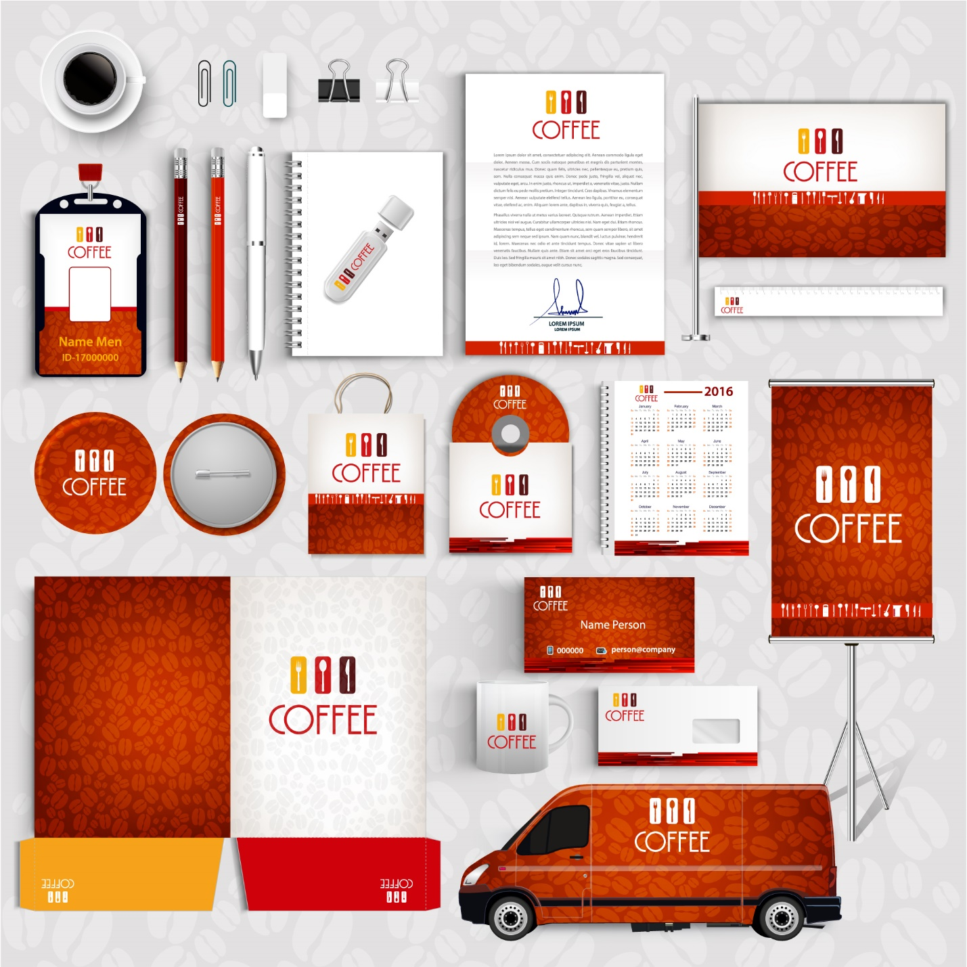

Corporate Branding Builds Authority
Corporate branding shapes public perception. Corporate branding design Dubai supports authority and credibility. It aligns internal and external messaging. Employees understand the company vision clearly. Clear branding improves team confidence. Stakeholders trust consistent brands. Corporate identity reflects company culture. Branding supports leadership communication. Authority builds through consistency. Corporate branding supports mergers and partnerships. It simplifies stakeholder communication. Strong authority attracts investors. Branding also supports crisis management. Trusted corporate brands recover faster. Authority ensures long-term stability.

Custom Branding Meets Unique Needs
Every business has unique goals. Custom branding design Dubai addresses specific needs. Custom branding avoids generic solutions. It reflects true brand personality. Businesses stand out authentically. Custom strategies target ideal audiences. Branding aligns with business vision. Flexibility supports innovation. Custom branding adapts to market changes. It supports niche positioning. Businesses gain a stronger identity. Custom branding improves relevance. It ensures brand consistency. Tailored solutions deliver better engagement. Unique branding strengthens differentiation.


Branding Drives Business Success
Strong branding drives measurable success. Business branding design in Dubai supports long-term growth. It improves recognition and loyalty. Marketing becomes more efficient. Customer trust increases steadily. Branding supports sustainable revenue. Businesses gain a competitive advantage. Strong brands attract better opportunities. Partnerships form easily. Branding reduces acquisition costs. Loyal customers stay longer. Brand equity grows over time. Businesses withstand market changes. Branding ensures relevance. Success becomes predictable and scalable. Branding remains a core business asset.

Conclusion
Branding plays a vital role in Dubai’s competitive market. It builds identity, trust and recognition. Strong brands grow faster and last longer. Branding improves customer experience and loyalty. It supports digital success and premium positioning. Cultural relevance strengthens acceptance. Strategic branding creates authority and clarity. Businesses that invest in branding gain an advantage. Branding design Dubai remains essential for long-term success. Many companies rely on trusted partners like saaddesign for guidance. Branding is no longer optional in Dubai. It defines how businesses survive and grow. Strong branding shapes future success.

Frequently Asked Questions
How often should branding be updated?
Branding should evolve with business growth and market changes.
Can branding increase sales?
Strong branding improves trust, which increases conversions and loyalty.
Is branding only visual design?
No. Branding includes values, messaging tone and customer experience.
